[](https://www.google.com.br/url?sa=i&rct=j&q=&esrc=s&source=images&cd=&cad=rja&uact=8&ved=0ahUKEwjVv5SPotjOAhVO_mMKHRiMCpgQjRwIBw&url=http%3A%2F%2Fnoticias.universia.com.br%2Fvida-universitaria%2Fnoticia%2F2013%2F07%2F24%2F1038550%2F1-000-alunos-escola-publica-tero-uma-nova-chance-na-fuvest-entenda.html&psig=AFQjCNErDCc5HMXwsU7pbx3dDniazYJtYQ&ust=1472066745664997)Lista de Livros

1. **Claro enigma** - Carlos Drummond de Andrade

[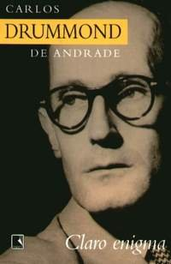](https://www.google.com.br/url?sa=i&rct=j&q=&esrc=s&source=images&cd=&cad=rja&uact=8&ved=0ahUKEwifoeLSotjOAhVB3mMKHYVeBpUQjRwIBw&url=http%3A%2F%2Flivroseresumos.com.br%2Fclaro-enigma%2F&bvm=bv.129759880,d.cGc&psig=AFQjCNFG_vOR3WQygY18VZMTrneOzCu7iA&ust=1472066885862260)

1. **Sagarana** - João Guimarães Rosa

[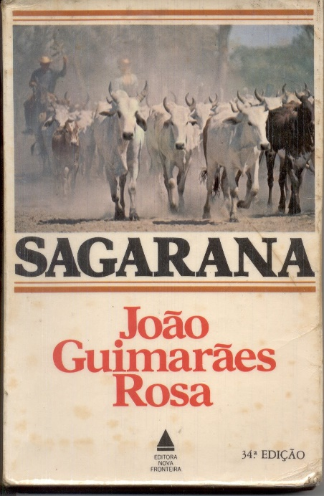](https://www.google.com.br/url?sa=i&rct=j&q=&esrc=s&source=images&cd=&cad=rja&uact=8&ved=0ahUKEwiuzoXcotjOAhUJ3GMKHbAkBLQQjRwIBw&url=https%3A%2F%2Fnuhtaradahab.wordpress.com%2F2009%2F05%2F24%2Fjoao-guimaraes-rosa-sagarana-parte-i%2F&bvm=bv.129759880,d.cGc&psig=AFQjCNHcy7T_bc3mmLfE2N4vFxGaalfkxg&ust=1472066906957557)

1. **Mayombe** – Pepetela

[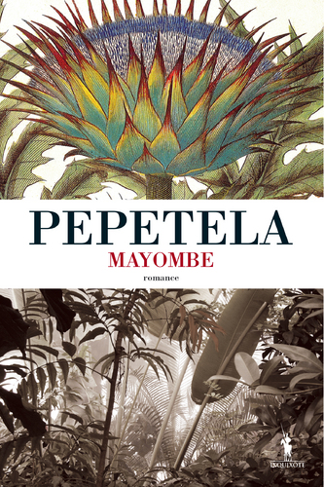](https://www.google.com.br/url?sa=i&rct=j&q=&esrc=s&source=images&cd=&cad=rja&uact=8&ved=0ahUKEwjx7drootjOAhUU32MKHdawCCYQjRwIBw&url=http%3A%2F%2Fwww.leyaonline.com%2Fpt%2Flivros%2Fliteratura%2Fliteratura-classica%2Fmayombe-2-2%2F&bvm=bv.129759880,d.cGc&psig=AFQjCNFcw12sYaq9lLUygipxwY8belTt2A&ust=1472066935209296)

1. **Iracema** - José de Alencar

[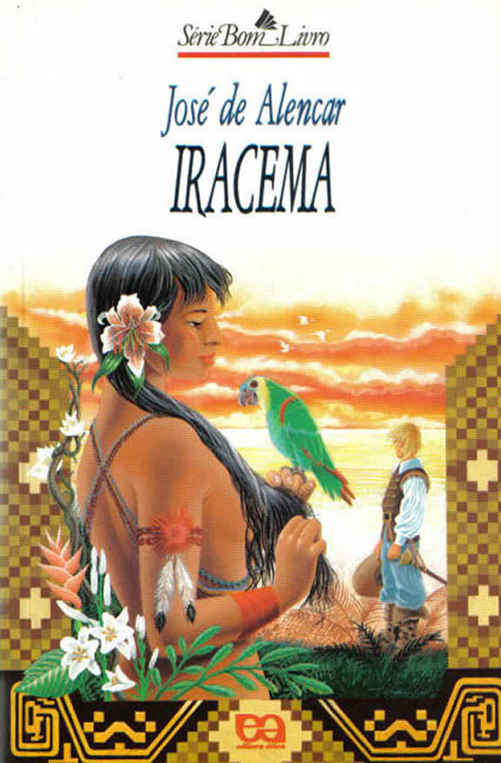](https://www.google.com.br/url?sa=i&rct=j&q=&esrc=s&source=images&cd=&cad=rja&uact=8&ved=0ahUKEwiZnrHoo9jOAhVNwmMKHbEYBVgQjRwIBw&url=http%3A%2F%2Fhomoliteratus.com%2Firacema-um-romance-subversivo%2F&bvm=bv.129759880,d.cGc&psig=AFQjCNEoer4fVGf1atlzXlhGjXfLqDJpPA&ust=1472066968750767)

1. **Vidas secas** - Graciliano Ramos

[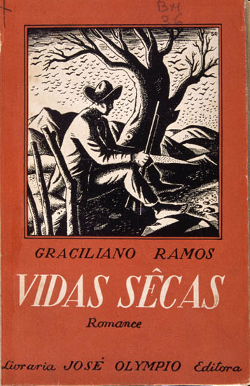](https://www.google.com.br/url?sa=i&rct=j&q=&esrc=s&source=images&cd=&cad=rja&uact=8&ved=0ahUKEwicv7_0o9jOAhVP7GMKHWWdB8UQjRwIBw&url=http%3A%2F%2Fguiadoestudante.abril.com.br%2Festudar%2Fliteratura%2Fvidas-secas-resumo-obra-graciliano-ramos-702011.shtml&bvm=bv.129759880,d.cGc&psig=AFQjCNE1b3hGi5aqLo_v_5OjfqplrDGBWg&ust=1472067228319953)

1. **Memórias póstumas de Brás Cubas -** Machado de Assis

[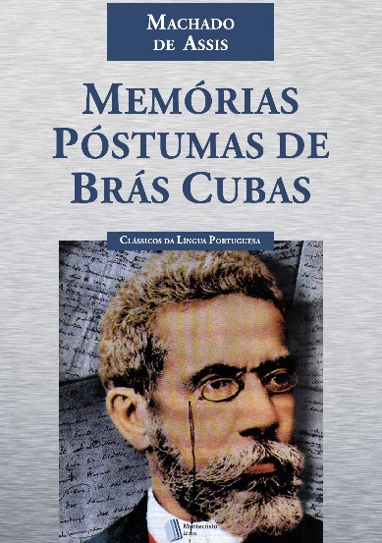](https://www.google.com.br/url?sa=i&rct=j&q=&esrc=s&source=images&cd=&cad=rja&uact=8&ved=0ahUKEwi5tPuCpNjOAhVI2GMKHZnBAT8QjRwIBw&url=http%3A%2F%2Fwww.clubedoresumo.com%2Fresumo-do-livro-memorias-postumas-de-bras-cubas%2F&bvm=bv.129759880,d.cGc&psig=AFQjCNGykGZ5uxpqXBiPI70ir5iLaGnC_w&ust=1472067258709994)

1. **O cortiço -** Aluísio Azevedo

[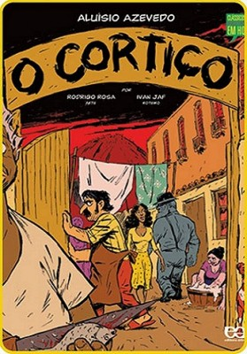](https://www.google.com.br/url?sa=i&rct=j&q=&esrc=s&source=images&cd=&cad=rja&uact=8&ved=0ahUKEwjjnfSapNjOAhVM6WMKHZeNDM0QjRwIBw&url=http%3A%2F%2Faprovadonovestibular.com%2Fresumo-de-o-cortico.html&bvm=bv.129759880,d.cGc&psig=AFQjCNHDaPP1kzu1PJl7g5DEzmCZlgQstg&ust=1472067304118506)